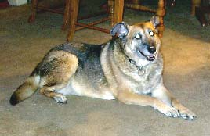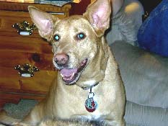

THESE 2 SWEET DOGS NEED TO FIND A NEW HOME A.S.A.P.
THEY HAVE A VERY SAD STORY – CAN YOU HELP?

We are Mandy & Pumpkin & we are very special dogs. We are 9 & 7 years old & have lived a very happy life with two wonderful owners. Our mom & dad were truly special & gave us lots of love & attention. We gave them lots of love in return & were never a problem. We got along with neighbors dogs & even got along with the cats that mom brought home one day.
We were a very happy family.

Our hard times began when mom got sick, she was sick for years & then needed the help of
a wheelchair. When she was at her worst she required round the clock care from a professional caretaker. We hated seeing mom so sick & didn’t understand what was happening to her. The saddest day was the day our mom died. We stayed with her as long as we could but then she was gone forever. Our dad was so sad, we never saw him that way. He cried for days. We tried our best to comfort him but we were also very sad.

Dad has lots of medical bills to pay because he did all he could for mom. Dad was retired but now he finds himself in a position where he MUST get a job in order to keep his house & pay
off mom’s bills. Dad told us that he loves us so much but there is no way that we can live in our house while he is traveling for months at a time. He told us that because he loves us so much he wants to find a new home for us, one that will be just like the one we grew up in.
He does not want to see us in a cage or in a shelter where we will be put to sleep. He knows that most people prefer puppies to older dogs & he fears that we will not be treated nicely.

Dad found a nice rescue group who has taken a real interest in us. The group is determined to find us a home. We already met two people from the group & we really think they liked us. We hope & pray that they can find us a home where we can stay together & live our lives out peacefully. If we need to be separated we will try to adjust as best as we can.

We will always have memories of our mom & dad & we hope that our new owners will understand if we cry a little in the beginning or act a little nervous. We are truly two wonderful dogs who only have love to give. Won’t you please help us find a home???

If you would like more information on Mandy & Pumpkin please call
LOVING TOUCH at (718) 224-8629 or (718) 820-9220.
An adoption application, vet check and interview
are required prior to adoption.

